**Adrian Schrage**

**Weekly Journal: Senior Design**

**Semester 1 & 2**

**Shocking Engineers**

**Week of September 10th**

* Discussed project idea and prepared for presentation.
* Planned weekly meeting and completed weekly minutes.
* Researched hardware, software, and needs of power for project.
* Began discussing future steps.
  + Discussed hardware options and communication between hardware.
  + Plans for purchases
  + Scope of project

**Week of September 24th**

* Began the research of technical hardware and software
* Decided upon appropriate candidates for service learning
  + [EmberHope](o%09https:/www.emberhope.org/how-we-help/foster-care-kansas/?gclid=CjwKCAiA1JGRBhBSEiwAxXblwY3hUTkM7Q1w_Y3gnOj0BiW2L7o4j-FwILvf1TLstDU9Nwsr2Mbu4BoCQDQQAvD_BwE)
* Formulated Project Planning Paper
* Discussed potential prototype implementation

**Week of October 17th**

* Studied heavily for the skills assessment (refreshing topics).
* Spoke with partner EmberHope regarding project paper
* Began the discussion of mechanical design
  + Objective: Study and learn CATIA V5 3D design software
* Discussed the weekly task at hand (Technical Paper)

**Week of October 31st**

* Setting up meeting with Partners
  + Ember Hope has set up a meeting to discuss any questions they have to further our partnership.
* Designed mock-up of product
  + Used CATIA V5 for first design idea
* Further Discussed implementation needs for design idea

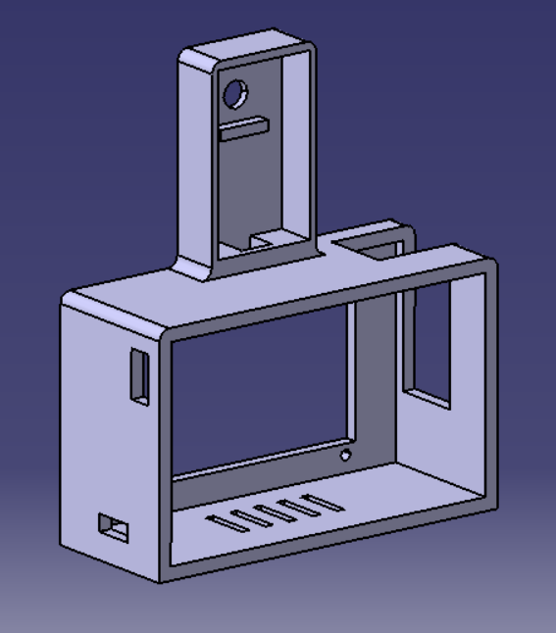 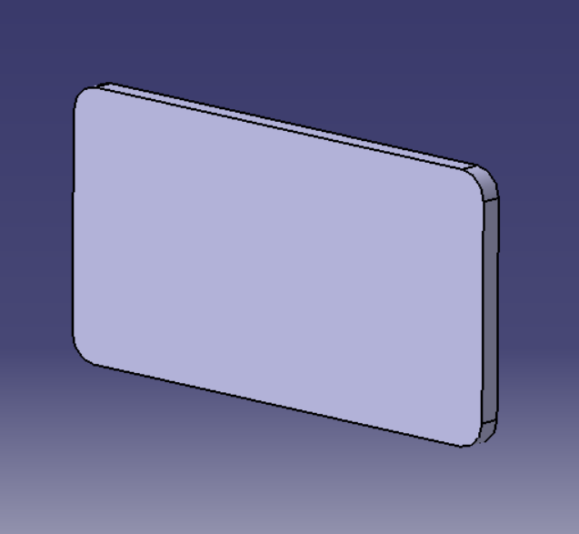

**Week of November 14th**

* Meeting with Ember Hope
  + EmberHope meeting took place this week and was a success. We spoke with their administration, and they are pleased with our idea. We plan to implement our product in one of their places of work next semester. We also plan on administering a survey to configure their thoughts on our product.
* EmberHope request; “Please make it optional”.
* Design Change meeting
  + As of the meeting with EmberHope we have had many discussions about a design change to accommodate their request. Making the design more of a modular and portable design is what we have decided will be best.
* Meetings have commenced about product showcase and what it pertains.
* Personal Product Reflection
  + [**Product Interview Reflection Paper.pdf**](Product%20Interview%20Reflection%20Paper.pdf)
* Individual product work package completed

**2022**

**Weeks of Jan 30 – Feb 13**

* Process of setting up meeting with instructor to make sure our team is prepared for the semester.
* Helping Lexi schedule and speak with Partners “EmberHope” to begin our first phase of testing.
* Started V2 prototype design using CATIA V5. (Decided to switch to Solidworks)
* From other members of the group: Hardware and software components have slightly change. FT added and switched to RB Pi 4B. This changed power needs.
* The planning for appropriate power supplies and ways of saving has begun.

**Weeks of Feb 13 – 27**

* Multiple meetings with group to identify upcoming group and individual goals and to prepare for two meetings with Dr. Stallard.
* Studying component sizes and starting design ideas for new prototype.
  + Ex. Raspberry Pi4 schematic drawing - <https://datasheets.raspberrypi.com/rpi4/raspberry-pi-4-mechanical-drawing.pdf>
* Began researching and experimenting to find a sufficient battery supply.
  + So far using a power meter we have found that the Raspberry Pi
    - Peak startup – 6.6 Watts
    - Idle with screen and fan on – 5.6 Watts
    - Running program (everything) – 8.6 Watts
  + So far, we will assume the Pi draws anywhere from 2.5 -2.75A at peak times. We can assume and verify from technical data given for Raspberry Pi that we need a 3A 5V power supply.
* One of our members is working on turning of the backlight on our LCD screen using a power switch and this can potentially save us 170mA at idle.